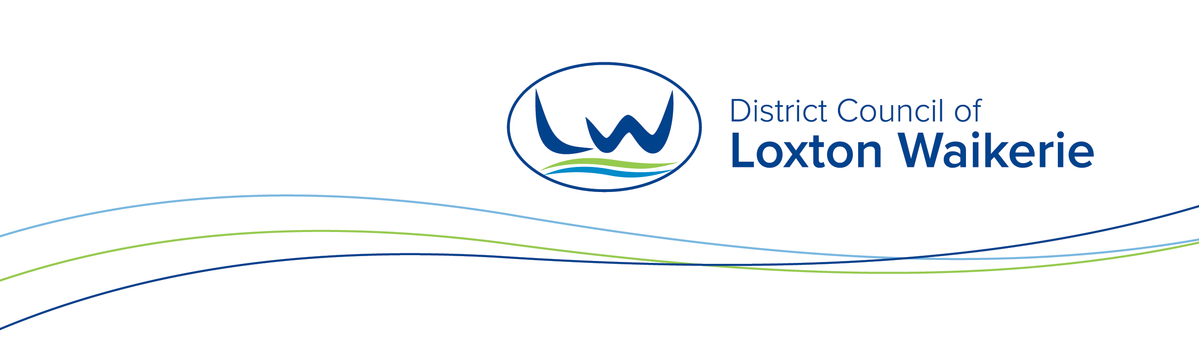

Event Management
DEBRIEF & EVALUATION FORM

SECTION 1 – EVENT DETAILS
Name of Event
Date of Event
Organisation
Attendees
Date of meeting
List or describe what you thought was successful or worked well in the area you were responsible for or involved in:
List or describe what you thought was NOT successful or did not work in the area you were responsible for or involved in

List Councils actions/recommendations for improvement of future events for the area that you were responsible for or involved in

List or describe what you thought was successful or observed working well in the whole event

List or describe what you thought was NOT successful or observed NOT working well in the whole event.

Refer to event action plan if applicable as part of this evaluation process. (List CM9 reference)

List your groups actions/recommendations for improvement of future events for the area that you were responsible for or involved in

Any further comments or recommendations for future improvements of the event:

